

Software Engineering Department

Ort Braude College

Capstone Project Phase A – 61998

**Social network for healthy life**

Project code: 23-2-D-11

**Supervisor:**

Dr. Zakharia Frenkel

**Authors:**

Reem Kadmany

[reem.kadmany@e.braude.ac.il](mailto:reem.kadmany@e.braude.ac.il)

Roaa Bader

[roaa.bader@e.braude.ac.il](mailto:reem.kadmany@e.braude.ac.il)

GitHub link: <https://github.com/roaab3/SocialnetworkForHealth>

**Abstract:**

Over time, online health communities and websites become more massive and full of unreliable information. As a result, finding trustworthy information can take a lot of time and effort. That's why we need a fast and reliable way to get trustworthy information from reliable sources.

Our goal is to enable users to share their personal experiences, rate, like, and discuss the efficiency and effectiveness of the data. In addition, the community will implement a profit-sharing model.

**Contents:**

Abstract …………………………………………………………………………………………. 2

1. Introduction …………………………………………………………………………………. 5
2. Background and related work ……………………………………………………………….. 6

2.1 Social impact of Community Generated Content ……………………...……………….... 6

2.2 Meritocracy ………………………………………………………………………………. 7

2.2.1 Problems caused by fake content in the CGC ……………………………………….. 7

2.2.2 Difficulties faced by the CGC due to limited content ……………………………….. 7

2.2.3 Ways to maintain CGC quality by paying moderators ………………………..…….. 7

2.2.4 Approaches through a merit-based algorithm ……………………………………….. 8

2.3 Meritocratic networks…………...……………………………. ……………………..…... 8

2.4 Meritocracy and social network for healthy life project …………………………………. 9

3. Expected achievements …………………...….……………..……………………………….. 10

3.1 Technology challenge …………………...………………………………………………. 10

3.1.1 Performance ………………….………………………………………….…………. 10

3.1.2 User experience ………………….……………………………………………….... 10

3.1.3 Security ………………….…………………………………………………………. 10

3.2 Criteria of success ……………….……………………………………………………… 11

3.3 Unique features ….……………………………………………………………………… 11

4. Technology choices ……………………….……………………………………………. 13

4.1 Technologies for Back-End ……………………….…………………………………….. 14

4.1.1 NodeJS ……………………….………………………………………….…………. 14

4.1.2 Express NodeJS ……………….…………………………………………………… 15

4.1.3 NestJS ………………………..………………………………………….…………. 16

4.1.4 MongoDB ……………………………………………………………….…………. 17

4.2. Technologies for Front-End …………………...….……………………………….. 18

4.2.1 ReactJS ………………………..………………………………………….…………... 18

4.2.2 NextJS ………………………..………………………………………….………….... 18

5. Engineering Process ………………...…………………………………………….…………. 19

5.1 Define app purpose …………………..………………………………………….………. 19

5.2 Algorithmic challenge ………………...…...………...……………………….…………. 19

5.2.1 Providing the meritocracy ………………...…...………...…………..….………....…. 19

5.2.2 Awarding system ………………...…...………...……………………….…..……..…. 19

5.2.3 Asking and answering questions …………………...….…………...……..………….. 20

5.3 class Diagram ……...……………....………...…………….………………………....…. 21

5.4 Use Case Diagram ………..…..…...…...………...…………….……………………..…. 22

5.5 Functionality ………………...….……….…...…………….………………………....…. 23

5.5.1 Logged user …….………………...………...…………….……………………..……. 23

5.5.2 Unlogged user ….……………….....………...…………….……………………..…... 24

5.5.3 Community member …...………….....…....………...…….…………………………. 24

5.5.4 Moderator…...………….………......………...…………….……………………..…... 24

5.5.5 Admin ….………………..……...…………...…………….……………………..…... 24

6. UI Characterization ………...………...…...………...…………….……………………..…... 25

6.1 Login/Register screen ………….………...…...……...……….……………………..…... 25

6.1.1 Log-in ………………..……...…...………...…………….……………………...…... 25

6.1.2 Sign-up …..…………..……...…...………...…………….……………………...…... 26

6.2 Profile screen ………………..……...…...…….…………….……………………...…... 27

6.2.1 Profile page .…………….……...…...…….…………….……………………....…... 27

6.2.2 Edit profile ……..……….……...…...…….…………….……………………....…... 28

6.2.3 Profile setting - security ………...………..……...…...…….…………….…………. 29

6.2.4 Invite users ……..……….….....…...…….…………….……………………....…… 30

6.3 Community page …………..…...………..……...…...…….…………….……………… 31

6.4 Posts …..…………..……...…...………...…………….……………………...………….. 32

6.4.1 Add a new post ………....……..……...…...…….…………….…………………….. 33

6.4.2 Edit post ……………...………..……...…...…….…………….…………………..… 34

6.5 Comments …..…………..……...…...………...…...….……………………...………….. 35

6.5.1 Author profile - comments ………...………...….…………….…………………….. 36

6.6 Search and search page ………...………..……...…...…………….…………………….. 37

7. Testing plan ………...………..……...…...…….…………….………………………………. 38

8. Resources …………………….………..……...…...…….…………….…………………….. 40

**1. Introduction:**

People who are receiving medical care and caregivers are using the internet for support more often. They rely on online groups, websites, and blogs to help them with their needs. Some online communication is replacing traditional doctor-patient communication, but it can provide helpful information and support that is not easily found anywhere else. More specifically, patients and caregivers are using online communities to search for health information.

An online health community (OHC) is an online chat group in which people can connect, share experiences, and seek/provide support. People who participate in these online chats usually want to find someone who faced a similar experience and learn from it.

There is not much agreement on the best way to create OHC, and there is a lot of research on its benefits. Even though there is limited research on its benefits, OHC still seems to be helpful for patients and caregivers in many situations. Such as providing valuable information about diseases and treatments.

One of the main reasons people use OHC is to share health information with untrained people.

In many cases, people don't make their best decisions when they share and trust information from online communities. However, using incorrect information can have harmful consequences and this can lead to serious negative effects.

To solve these problems, our project will use a meritocracy network where the reliability of information is based on the talent, effort and achievements of the user. Furthermore, we will implement a share-profit model where users can gain profits based on their posts, and this will encourage experts to join our community.

* This project is a follow-up project to another project that failed to enter the market, and our purpose is to improve the previous project. Our project is different from the other in the GUI and functionality. In our project, the users can join small/big groups and this will improve the performance on the website. In addition, the previous project did not have a lot of activities that can be offered to the user, meanwhile we expanded the activities of the user. Also, in our project there are experts that will provide the reliability of the content.

**2. Background and related work:**

**2.1 Social impact of Community Generated Content:**

A growing body of evidence suggests that community-generated content (CGC) on platforms ranging from Yelp to Facebook has a large causal impact on economic and social outcomes ranging from restaurant decisions to voting behavior.

We look at how CGC influences the behavior and structure of markets and highlight potential areas for future research [1]. Recently, consumers are increasingly making purchasing decisions based on reviews authored by fellow community members rather than relying on professional reviewers.

Examples of online services that show how reviews affect your business:

Amazon:

According to research that was led by Bazaarvoice most U.S. shoppers (56%) identified customer reviews as the primary e-commerce feature they depended on to make informed purchase choices. [2]

Yelp:

By merging the ratings given to restaurants on Yelp with sales information for every restaurant that operated in Seattle over six years, according to the findings of Luca’s study in 2011 an independent restaurant experiences an almost 5% rise in sales with each additional star in their Yelp rating, while such as increase does not affect chain restaurants. This result supports the idea that customers already have more knowledge about chain restaurants, so they rely less on Yelp to learn about them.[1]

eBay:

One clear effect of this review is how the rating given by buyers affects the price at which a seller can sell their item.

This shows that when a seller on eBay receives negative feedback, they can expect to receive more negative feedback around 25% quicker than before according to a study conducted by Cabral and Hortaҫsu (2010). As we can see, the main concern in reviews is assessing how reliable each person is, rather than judging the quality of the product. [1]

**2.2 Meritocracy:** a reliable approach to make sure the quality of CGC is maintained.

**2.2.1 Problems caused by fake content in the CGC:**

One of the primary benefits of CGC is that it provides social proof. Social proof means that when people see others doing something, they are more likely to do the same, especially those who have used the product. According to [Stackla](https://www.businesswire.com/news/home/20190220005302/en/Stackla-Survey-Reveals-Disconnect-Content-Consumers-Marketers), 79 percent of people when they see content created by other users, it strongly affects their decisions.[3]

While CGC can have many benefits for businesses, it can also have negative impacts if not managed properly. The main issue in content production is maintaining control over content quality, and this issue has become increasingly important. Content quality is important because people rely on reviews and recommendations to make decisions regarding their time and money.

Yet the challenges are massive, They are a result of the advantages of CGC. The normal editorial solutions are not feasible, since the editors cannot go through hundreds of millions of reviews.

**2.2.2 Difficulties faced by the CGC due to limited content:**

A useful tactic that you can do to achieve good quality CGC is to identify the reviewer. Their name, where they are from, and if they are an employee. Offering this level of detail increases trust and helps to give confidence to the customers that the brand isn’t keeping secrets or spreading false information.

**2.2.3 Ways to maintain CGC quality by paying moderators:**

A way to ensure quality is to adopt a pre-moderation process where content is reviewed. This allows moderators to filter out any inappropriate or low-quality submissions.

Amazon revealed that they've invested more than $400 million to protect customers from review abuse and other types of misbehavior. They also stopped more than 13 million attempts to post fake reviews and took action against more than five million people trying to manipulate reviews[4].

**2.2.4 Approaches through a merit-based algorithm:**

* Verified Purchase

The common verified purchase feature shows potential buyers that the review is real because they have purchased the product. This label helps other customers assess the reliability of the review.

* Reviewer Sorting

When customers provide feedback, Amazon asks very specific questions about their buying experience and who they are. Reviewers are sorted into three categories to give other consumers a better idea of the review's true feelings.

* Personal profiles of the reviewers

This feature, which is inspired by the meritocratic network, allows users to check the reliability of a reviewer. By looking up their profile, the users can see their overall scores for helpful reviews and the other products they have reviewed.

**2.3 Meritocratic Networks:**

To handle complex content effectively, it is recommended to use meritocratic networks because they offer many advantages. These networks give priority to talent, effort and achievements, making sure that reliable and trustworthy information becomes more visible and recognized.

We will give a summary of one algorithm and explain the methods and techniques used by the most important merit-based networks:

**Reddit**

Reddit is a platform that prioritizes the feedback of its users when it comes to what it shows first. It has a unique system, where users can like/dislike and this can help to identify what people are interested in, and what they don't. Using this information, Reddit can quickly go through a lot of posts to bring attention to content that other users have found valuable. [6]

Reddits' posts ranking: [7]

* When it comes to submission, the time of posing is very important. Usually, more recent stories are given higher ranking compared to other ones.
* The count of the upvotes will not be considered in the ranking. For example, a story with 10 upvotes and a story with 50 upvotes will have the same ranking.
* Controversial stories that get similar amounts of upvotes and downvotes will get a low ranking compared to stories that mainly get upvotes.
* If a story has a similar number of upvotes and downvotes it will have a lower ranking compared to stories that mostly received upvotes.

**2.4 Meritocracy and Social Network for healthy life project:**

Individuals are rewarded based on their abilities, talent and achievements and not based on their social or economic background[5]. At the same time, the huge success of Reddit suggests that meritocracy algorithms are a very powerful tool.

The availability of medical information on the Internet is relatively limited compared to many other domains of knowledge. For example, one major issue is that existing platforms do not offer a way to ask important questions and get reliable answers on time.

Our project aimed to make use of the most effective existing approaches and develop new ideas.

**3. Expected achievements:**

In our project we expect to create an online health community that offers reliable and trustworthy information, support, and motivation that enable individuals to take control of their well-being quickly, using recommendation technologies.

**3.1 Technology challenges:** The success of a web application relies on various elements that can be challenging. The ability to overcome these challenges determines whether the web platform achieves success or falls short.

We will present some of these elements:

**3.1.1 Performance:**

Web applications need to be fast loading, responsive and reliable to meet the needs of today's online audience. Poor performance can be a result of inefficient code, inefficient databases and much more.

For example, we will use MongoDB because one of its features is that it backs up old and unused data and removes it, and by doing that we can optimize the performance of the database.

**3.1.2 User experience:**

This is the process of building products that are useful, easy, and enjoyable for people to use. Within an organization, the purpose of user experience design is to consider how a product, app, or website experience makes the user feel, how an interface looks, and how easy it is for the user to accomplish their goals.

In our project, we are going to use ReactJS as the back-end since it uses DOM that efficiently updates and renders the user interface. This improves the performance of the application. As a result, we get a smoother and more responsive user experience.

**3.1.3 Security:**

In today’s modern area, It’s not surprising that websites are a top priority for hackers. Therefore, security should be considered in each stage of the software development life cycle, especially when the application is dealing with essential information such as medical care data.

To overcome these problems:

1. We will validate all the input data, and use sanitizing methods to protect our app from XSS attacks.
2. We will use google clouds VM firewall to prevent unauthorized access.
3. To defeat a CSRF attack, we will use a CSRF token. The token needs to be unique for every user session

**3.2 Criteria of success:**

* A final website where users can seek fast and trustworthy information about health topics.
* The website will let users offer and use services based on its functionalities.
* Fast performance and easy-to-use user interface.
* The ranking system will rank the users’ activities based on their achievements using the meritocracy network.

**3.3 Unique features:**

* Chat: through chat, users can start conversations, ask questions, and share experiences. This feature encourages active participation within the social network.
* Ranking system: enable ranking the activities of a user such as posts/comments based on their relevance to the topic.
* Asking and answering questions: this feature allows individuals to seek guidance or advice from the community regarding various health-related topics. Users can post their questions, and members can provide answers based on their experiences.
* Privacy: By prioritizing privacy, the social network aims to create a safe and trusted space. For example, if a user attends a lecture, and the doctor/expert is explaining instructions to something, the user can send a video that only the doctor/expert can see, to make sure that he is doing it correctly.
* Service history: within this feature, the users can easily reference their past activities, progress, and achievements. Moreover, this feature allows users to revisit past resources, recommendations, or advice received.
* Awarding system: the system will encourage user activities by obtaining a bonus for each user based on their actions.
* Online lectures: every expert user could start live lectures and allow other users to watch and get benefits from them.
* File directory: a centralized system that organizes and stores shared files, enabling easy access and efficient collaboration among community members.
* Anonymous counseling: is a confidential support service that allows individuals to seek guidance, advice, and emotional assistance without revealing their identity.

**4. Technology choices:**

When we talk about developing software webs or applications we need to consider two things: frontend and backend.

For the back-end, we chose several options including NodeJS, MongoDB, and Nest. And for the frontend, we chose reactJS and nextJS.

In our project, we will use React to create the client browser, and then the client will send a request for data to the server. After that, The server will retrieve the data that was requested from the MongoDB database and send it back to the client and the pages will be re-rendered with the received data.

From that point, only the updated data on the server is sent back to the client, and then React re-renders the specific components of the page that require updating.

The diagram below shows the technologies that we chose in the front-end and back-end:

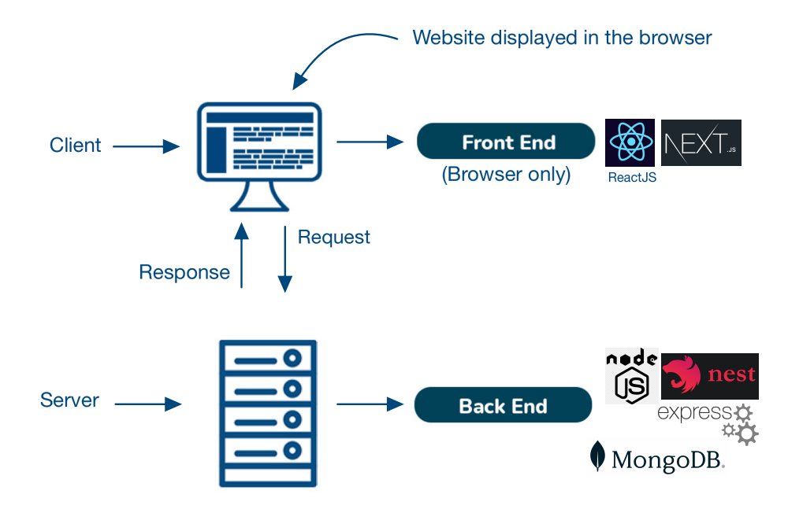

Figure 1

**4.1. Technologies for Back-End:**

**4.1.1 NodeJS**



Node.js is an open-source and cross-platform JavaScript runtime environment, it allows developers to write server-side code using java script. It runs the V8 JavaScript engine, the core of Google Chrome, outside of the browser. This allows Node.js to be very performant.

It provides a set of asynchronous I/O primitives in its standard library that prevent JavaScript code from blocking and generally. Moreover, A Node.js app runs in a single process, without creating a new thread for every request. [8]

Now that we’ve covered what NodeJS is, let’s take a closer look at some of its key benefits:

NodeJS benefits

1. High performance.

2. Easy to learn and quick to adapt.

3. Offers easy scalability.

4. It targets all major platforms.

5. Flexible

NodeJS drawbacks

1. Unable to process heavy computational tasks.

2. Unstable API.

3. Lacks a strong library support system.

In conclusion, NodeJS is an excellent option for developers who want to build highly scalable applications with JavaScript. And most important that it can be used for back-end servers and front-end.

**4.1.2 Express NodeJS**



Express is a small framework that sits on top of Node.js’s web server functionality to simplify its APIs and add helpful new features.

It is used to build a single page, multipage, and hybrid web application. It provides a powerful set of features to efficiently manage routes, requests, and views along with a beautiful boilerplate for your web applications.[11]

Moreover, several such platforms are unable to handle a higher level of requests, but with the help of Express.JS, you would be able to handle requests efficiently as it offers you the support of I/Q request handling.

Express benefits

1. Fast

2. Easy to learn.

3. Saves a lot of coding time.

4. Fast server-side development.

5. Makes it easier as it identifies the exact part where bugs are.

Express drawbacks

1. Error messages are challenging to understand.

2. Issues with the callbacks.

Finally, express is a flexible framework that helps developers create web applications quickly.

**4.1.3 NestJS**



Nest.JS is a popular framework used for building NodeJS server-side applications.

Since it’s built using TypeScript it allows developers to build highly scalable and testable applications. It also can enable developers to code purely in JavaScript and would let you combine the concepts of OOP, FRP and FP.

It also provides a modular application architecture, and this allows developers to create highly scalable, loosely coupled, and easily maintainable applications. It also helps speed up web app development time by offering solutions to code organization strategy problems.

NestJS features:

Nest.js is built on top of the powerful Node.js platform, providing fast performance and efficient resource utilization. Also, it provides a testing module that makes it easy to write tests and ensures the reliability of applications.

Moreover, it is easily expandable, as it can be used with other libraries and this enables Flexibility and Reduced Development Time. It’s also been considered the fastest-growing Node.js framework for the past 3 years.

Nest.js provides an easy way to develop and manage microservices, and this helps developers to break down complex applications into smaller, more manageable components. [9]

**4.1.4 MongoDB**



MongoDB is an open-source document-oriented NoSQL database, Data in MongoDB is stored in documents with key-value pairs instead of using tables and rows. This makes the data more flexible when compared to SQL databases. MongoDB is used to store a large scale of data while still performing rapidly. It also has a flexible data model that enables you to store unstructured data. [10]

Features:

MongoDB offers several features, including:

1. Flexible.

3. Provides high performance.

4. Stores files with all sizes easily without complicating the stack.

5. Easy to administer in the case of failures.

6. Integrates with a wide range of tools and platforms.

**4.2. Technologies for Front-End:**

**4.2.1 ReactJS**



React is an open-source, JavaScript library for developing user interfaces (UI) in web applications achieving faster results with less code. [13]

React allows us to create reusable components that each component is an individual piece of a final interface. As a result, ReactJS combines the speed of JavaScript.

The primary role of react in the application is to handle the view layer of that application and make sure they are displayed in efficiency. [13]

**4.2.2 NextJS**



Next.js is an open-source web development and front-end framework that is based on React, Webpack, and Babel. It allows you to build full-stack Web applications for different platforms. In addition, it takes care of the necessary tools and configuration that is required for React, while also offering additional structure and features. [12]

NextJS features:

One of its features is that It automatically reloads the application when changes in the code get saved, and that makes it easier for the developer. Moreover, unnecessary code never gets loaded on the page. This can help to improve the speed and performance of websites and applications.

**5. Engineering Process:**

**5.1 Define app purpose:** in the beginning, we defined the purpose of our website, and the problem that the website is going to solve: build an online health community where users can find reliable information.

**5.2 Algorithmic challenge:**

We faced several challenges, we will explain the task and our solution for the three main challenges.

**5.2.1 Providing the meritocracy:**

* The task: readers should have the option to filter content based on its reliability.
* Our solution: in our system, each community has an expert that is picked based on his talent and he will provide the reliability of content, while the moderator removes the irrelevant content.

**5.2.2 Awarding system:**

* The task: the system should encourage the users’ activities (adding posts/comments) to motivate them to stay active on the social network.
* Our solution: In the system, the users have the opportunity to add posts that are only visible to their friends. Also, the system includes a feature where the user can consult anonymously to make sure that he is comfortable while sharing/seeking advice about his health journey.

Moreover, in the system, the article’s popularity will be calculated according a formula:

$$Articles' popularity=sum of reads+likes*10-dislikes*5$$

The experts have an increased number of likes/dislikes. The number will be multiplied by the expert weight.

The popularity will be calculated for the last hour/day/month/year since posting, so the user can filter based on hour/day/month/year.

Additionally to that, each user will receive a bonus based on his activities (adding comments/posts, adding reliable content, and more/answering questions).

**5.2.3 Asking and answering questions:**

* The task: our task is to answer optimal and reliable answers for a wide range of questions as much as possible, and have the ability to search for similar questions that have been answered.
* Our solution: on the website, when the user gets the answer he will be able to estimate the answer based on its relevance to the question. If the user finds the relevant answer then the status of the question will change to “answered” and be added in a thin noticeable frame, and it has a separate icon that stands first and separately "Best Answer".

Also, the user will be able to sort the answer by date/user’s experience, etc. Meanwhile, the questions will be ordered according to the date/tag, etc.

Moreover, The user can search for similar questions that have been answered earlier to know the answer to his question in a fast way.

Bonus for answering: to encourage the user to answer more questions he will gain a 30 point bonus for each answer. Furthermore, for a helpful answer, he will get 60 points extra.

**5.3 Class Diagram:**

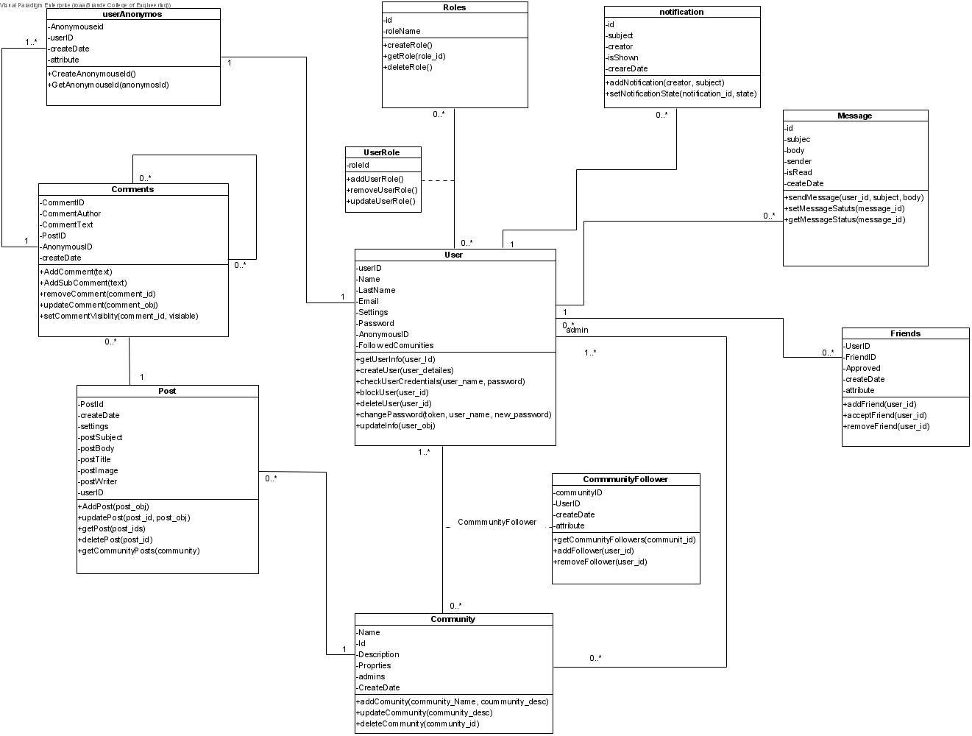

Figure 2.1

**5.4 Use Case Diagram:**

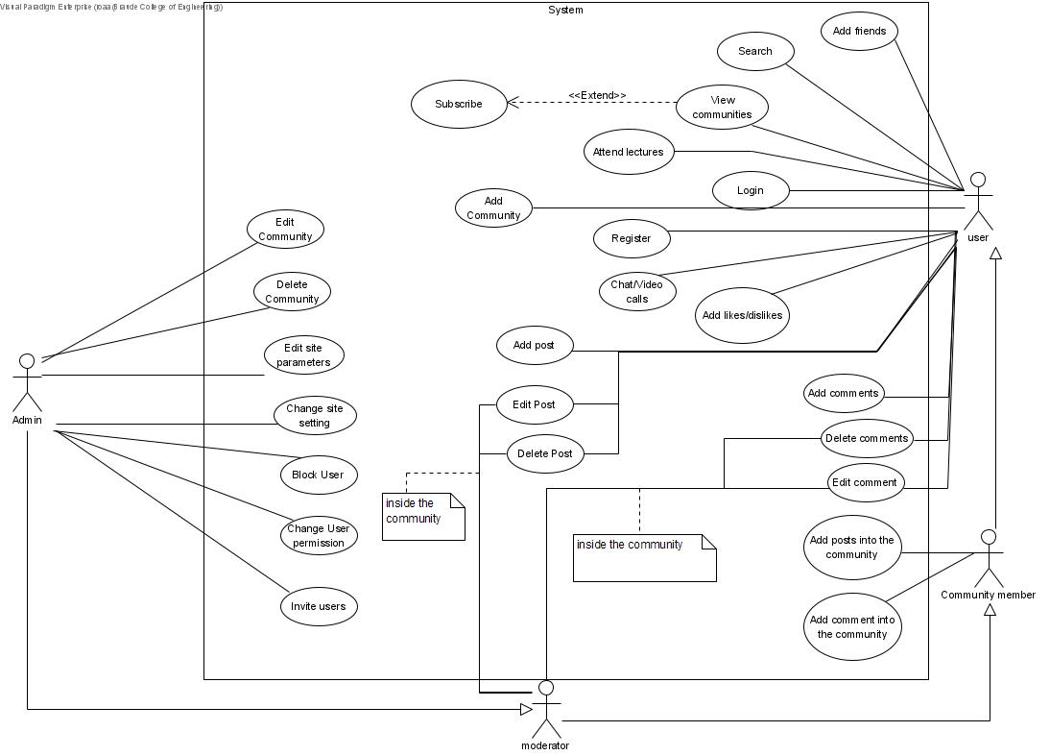

Figure 2.2

**5.5** **Functionality:**

Our website has several interfaces:

* Logged user
* Unlogged user
* Community member
* Admin
* Moderator

Each interface has its functionality.

**5.5.1 Logged user can:**

* Do any search.
* Add friends.
* Chat with friends: the user can send messages, videos, audio, and pictures.
* Video call his friends/group of friends
* Attend lectures that are given by a doctor/expert, and they also have the option to send a video that only the doctor can view.
* Have a file directory where he can save books, videos, and audio.
* Add, delete, and edit comments.
* Add, delete, and edit posts.
* Share videos as posts.
* Add likes/dislikes to the posts.
* View communities.
* View the profile of each author and which communities the author is a member of.
* Create new communities.

**5.5.2** **Unlogged user can:**

* Do all the viewing functionalities that the logged user can do, but only for a specific time. After that, he will have to sign-up just like the rest of the interfaces.

**5.5.3** **Community member can:**

* Add posts to the community.
* Add comments on communitie’s posts.
* Add likes on communitie’s posts.

**5.5.4** **Moderator can:**

* Do all the activities that the user and a community member can do.
* Delete and edit comments from the community.
* Delete and edit posts from the community.

**5.5.5** **Admin can:**

* Do all the activities that the moderator can do.
* Delete and edit the community.
* Change user permission.
* Block user.
* Change site settings.
* Edit site parameters.

**6. UI Characterization**

**6.1 Login/Register screen:**

On this screen, the user can log in different ways - using their email or social network user (Facebook/Google/Twitter). All of these options will bring the user to enter his details. After that, the process will check the login parameters if valid or not.

If the user is new, he can register to the web by clicking “join now”, or signing in with social media accounts will register the user automatically if he is not registered already.

**6.1.1 Log-in:**

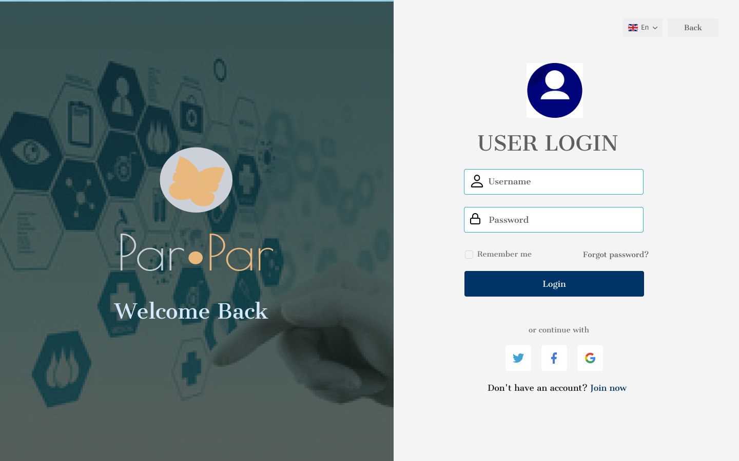

Figure 3.1

**6.1.2 Sign-up:**



Figure 3.2

**6.2 Profile Screen:**

The profile page displays the user info, recent posts, followers, posts count, likes count, comments count, and contact info. On this screen, the user can edit his details like email, picture, etc. Users can do it by clicking on the “Edit Profile” button. Also, he can change his password. The admin can invite users to the community.

**6.2.1 Profile Page:**

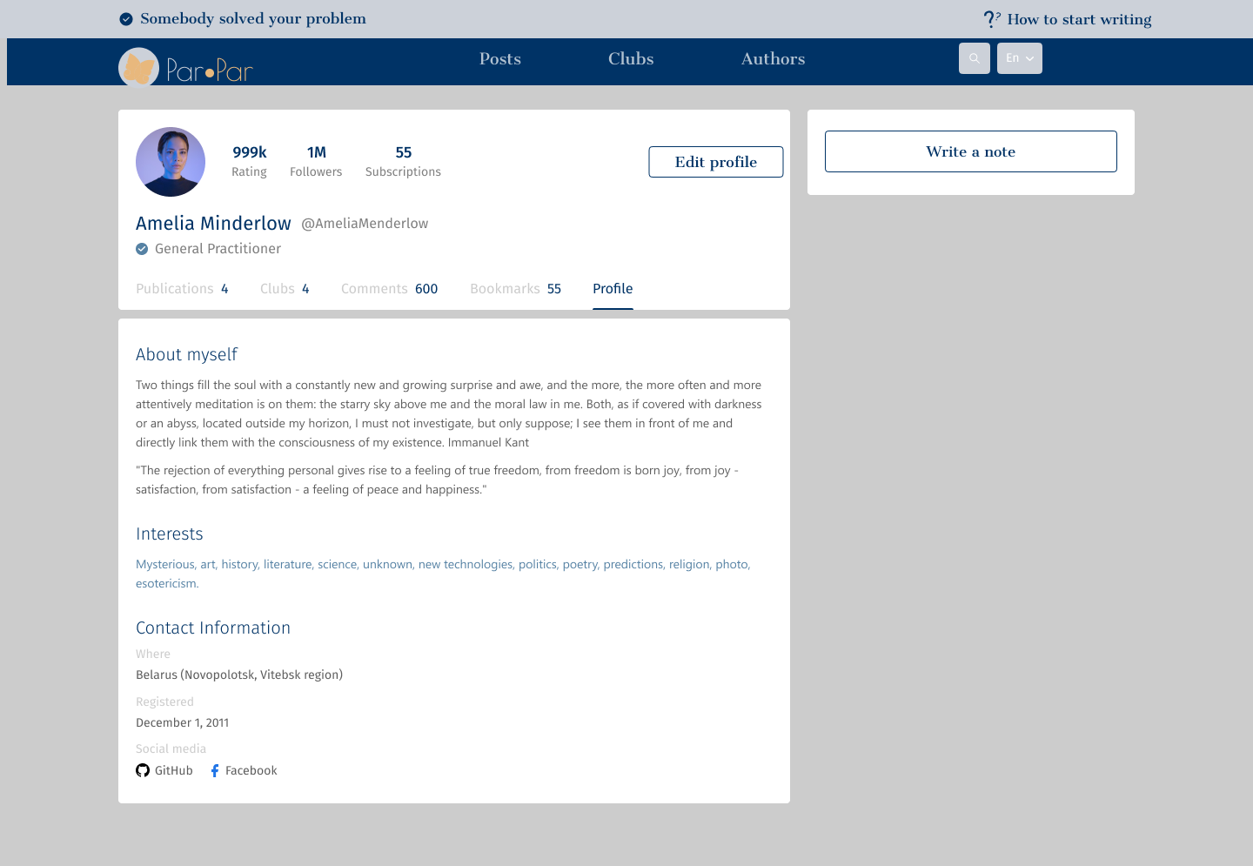

Figure 3.3

**6.2.2 Edit Profile:**

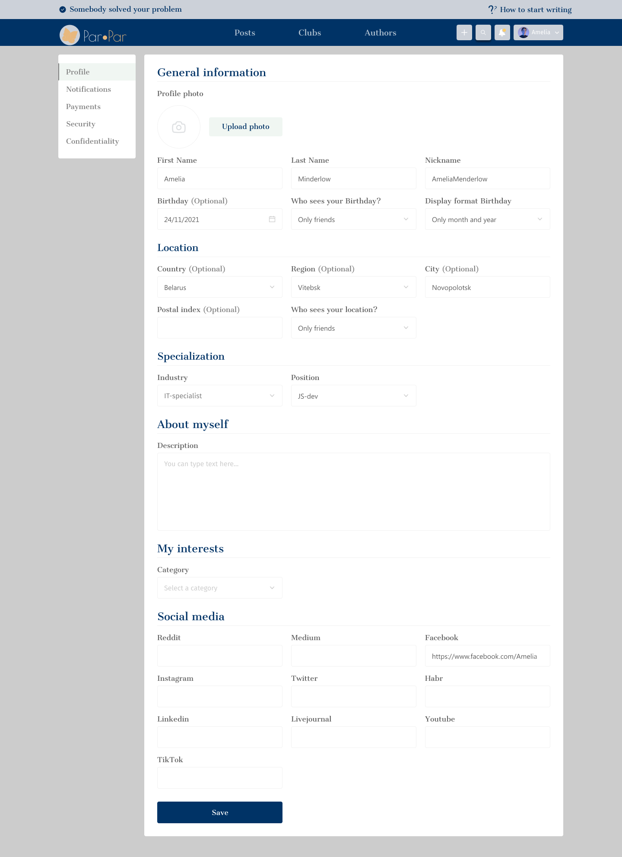

Figure 3.4

**6.2.3 Profile setting - security:**

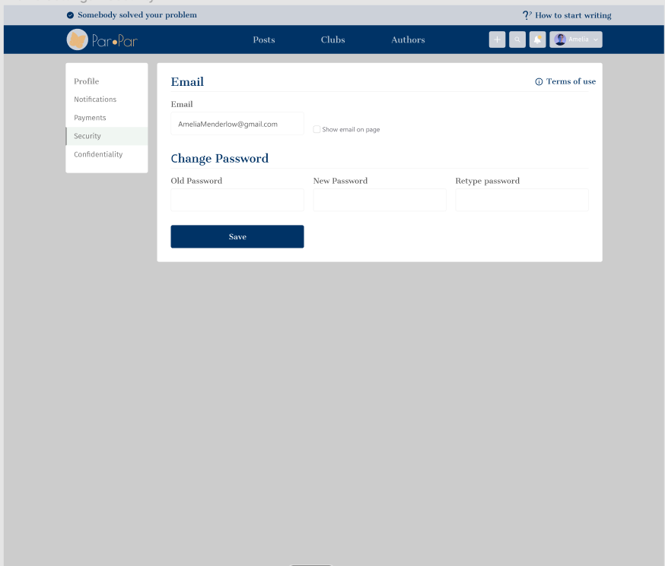

Figure 3.5

**6.2.4 Invite users:**

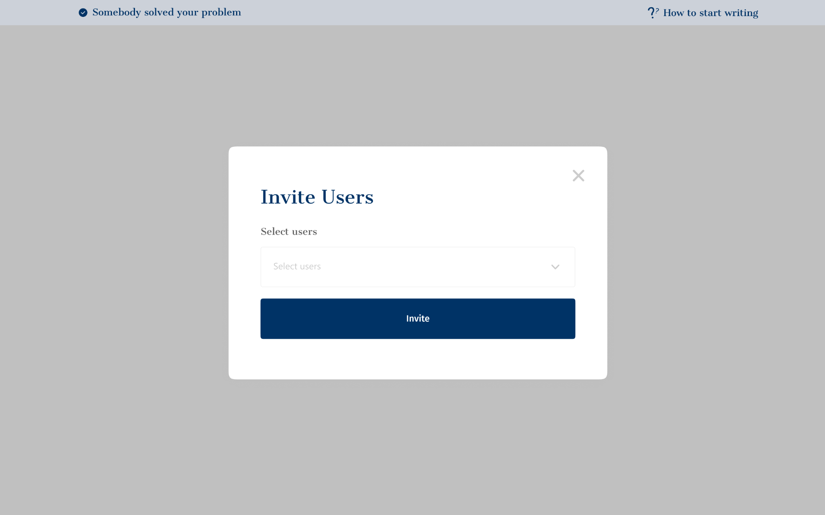

Figure 3.6

**6.3 Community/clubs page:**

Admin can create new communities, or edit if it's already created. Also, he can delete the community.

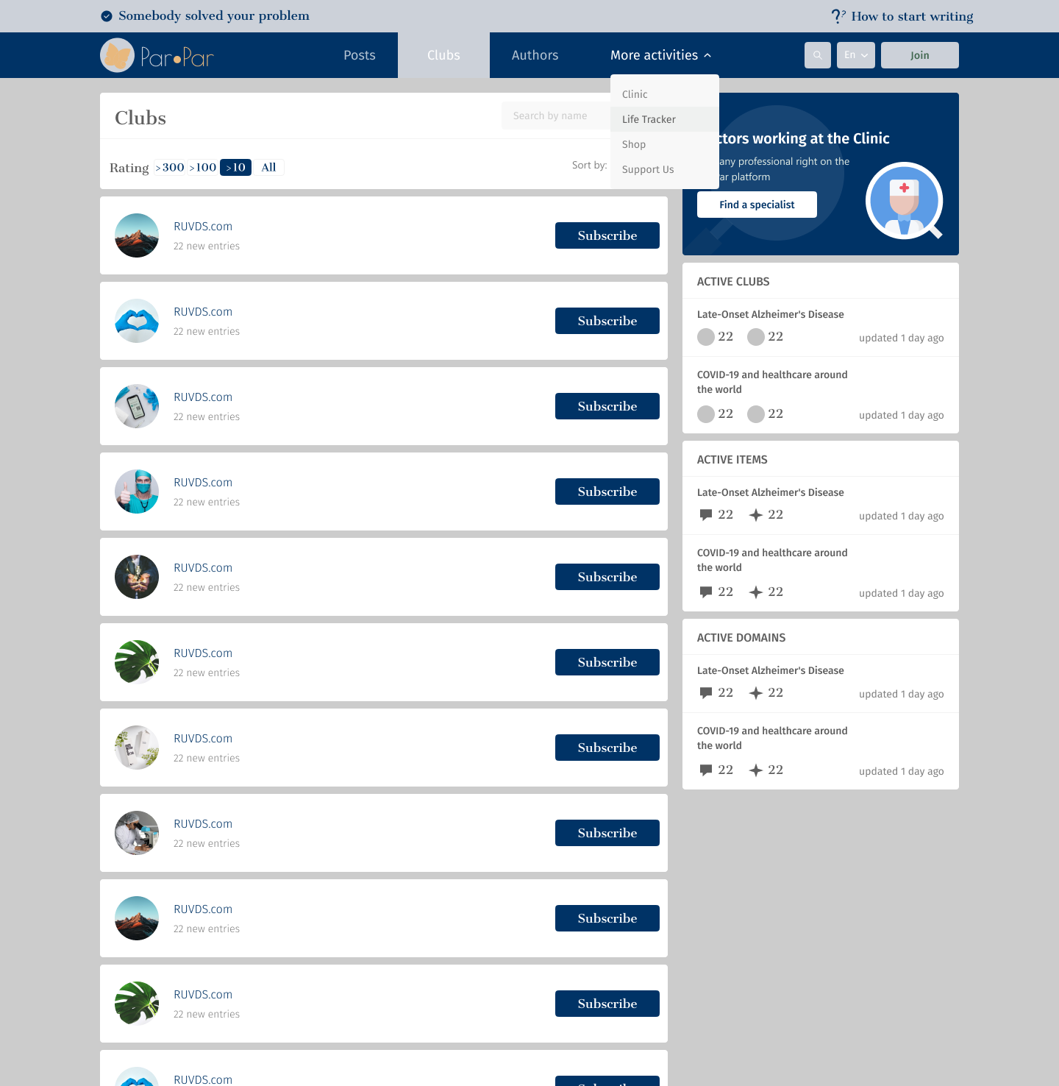

Figure 3.7

**6.4 Posts:**

Registered users can add new posts. The post can be edited by the writer or moderator, and deleted by the writer or admin.

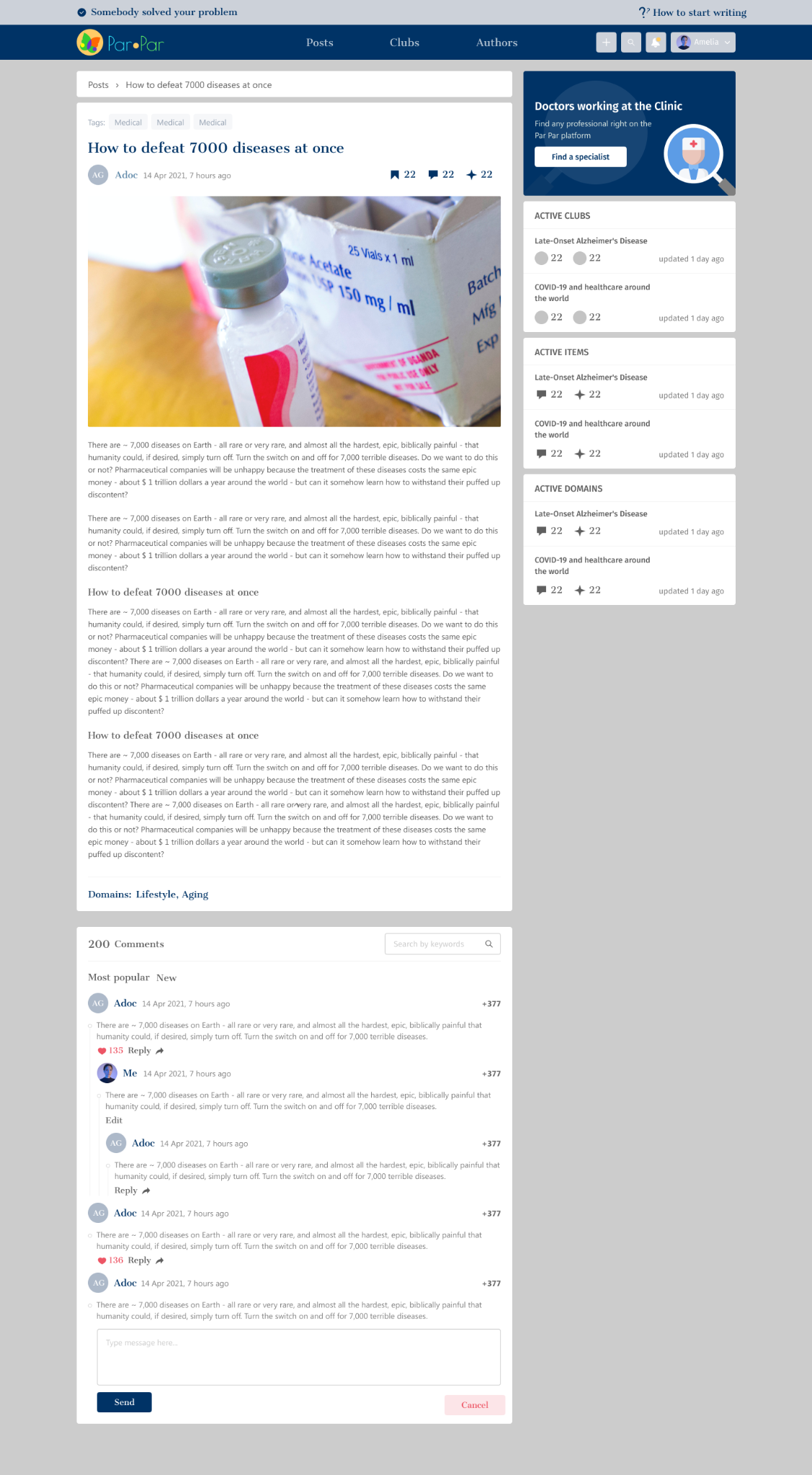

Figure 3.8

**6.4.1 Add a new post:**

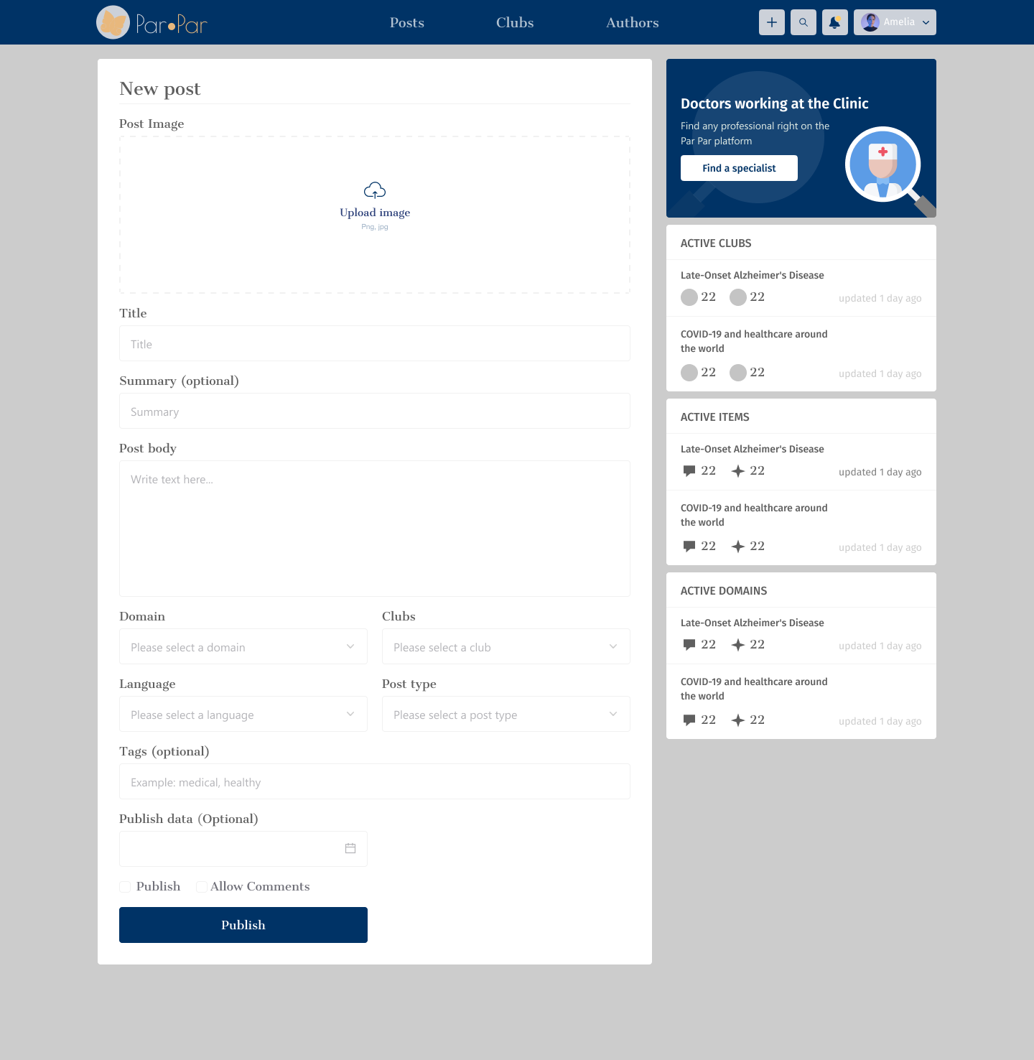

Figure 3.9

**6.4.2 Edit post:**

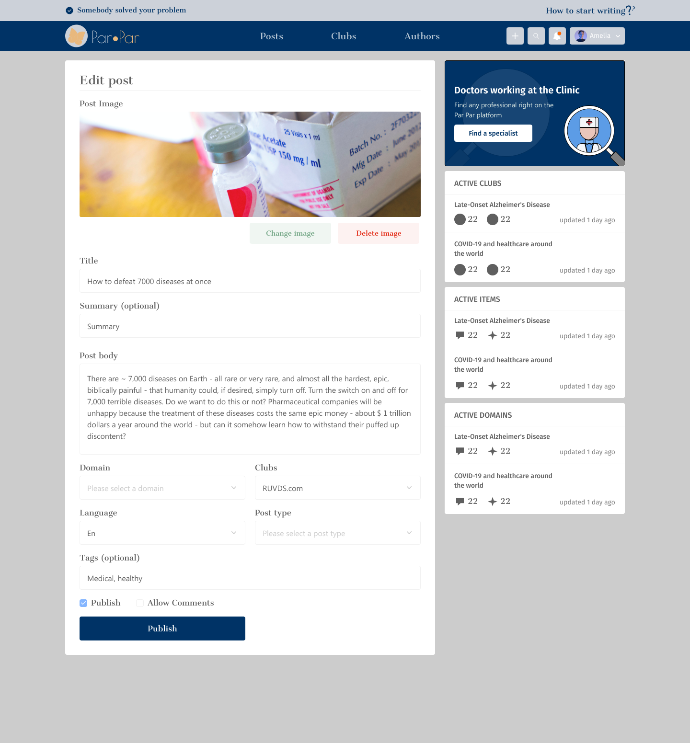

Figure 3.10

**6.5 Comments:**

Registered users can add comments. The comments’ text can be edited/deleted by the writer or moderator.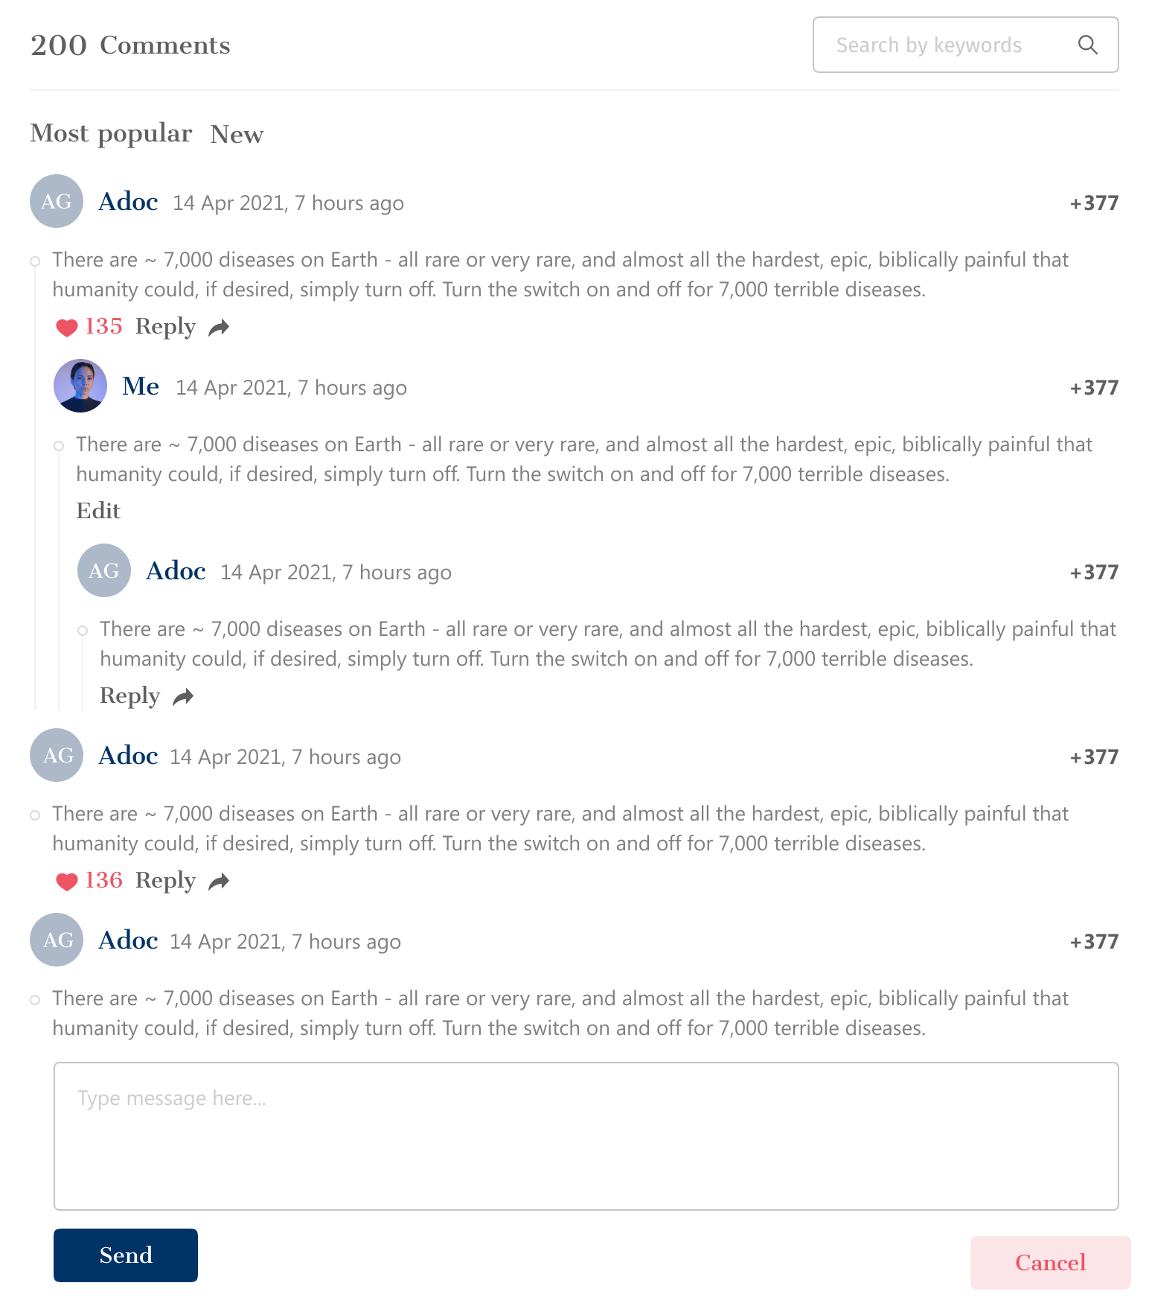

Figure 3.11

**6.5.1 Author Profile - comments:**

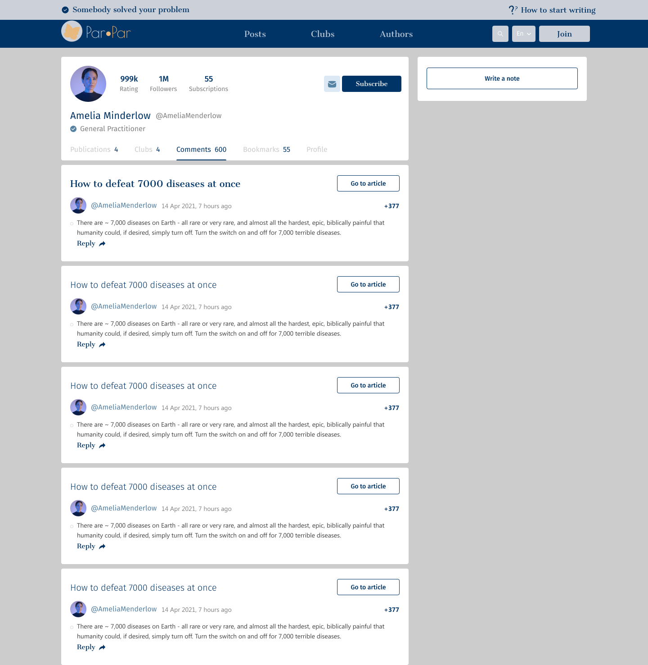

Figure 3.12

**6.6 Search and search page:**

Search on the app bar will display in a dropdown the top 5 search results based on the writing text. The search is a simple text box whose value will be used to search the post’s body titles. As a result, clicking the site will be redirected to the selected post.

Clicking on advanced search on the website will be redirected to the search page where all results will be displayed, and more filter options will be available.



Figure 3.13

**7. Testing plan:**

|  |  |  |  |
| --- | --- | --- | --- |
| **Test. number** | **Test description** | **Expected Result** | **Comments** |
| 1 | The system allows users to sign-up for the system | The user will be automatically logged in | Display a message “Successfully signed up” |
| 2 | The system doesn't allow the user to sign-up with an existing email | The sign-up failed, and an error message will be displayed | Display an error message “This email already exist” |
| 3 | The system allows existing users to log in to the system | The user will be logged in, and the home page is loaded |  |
| 4 | The system doesn't allow non existing users to log-in to the system | The log-in failed, and an error message will be displayed | Display an error message “This username is not found” |
| 5 | The system doesn't allow a user to log in with a wrong password/empty details | The log-in failed, then an appropriate  message will be displayed | The fields will be marked in red |
| 6 | The system allows the user to add post | The post is loaded and displayed |  |
| 7 | The system doesn't allow the user to create an empty post | Failed to create a post | The required fields will be marked in red |
| 8 | The system allows the user to a delete a post | The post is removed from the community | The post is deleted and is not found anymore |
| 9 | The system allows the user to update a post | The post is updated and loaded again in the community |  |
| 10 | The system allows the user to add a comment | The comment is loaded and displayed |  |
| 11 | The system doesn't allow the user to add an empty comment | Failed to create a comment and the required fields will be marked in red |  |
| 12 | The system allows the user to delete a comment | The comment is removed from the list | The comment is deleted and is not found anymore |
| 13 | The system allows the user to update a comment | The comment is updated and loaded again list |  |

**8. Resources:**

[1]Luca, M. (2015, May 5). User-generated content and social media. SSRN. <https://papers.ssrn.com/sol3/papers.cfm?abstract_id=2549198>

[2] [A Short History Of Amazon’s Product Review Ecosystem, And Where We Are Today| by Kiri Masters](https://www.forbes.com/sites/kirimasters/2021/03/22/a-short-history-of-amazons-product-review-ecosystem/?sh=2f3da5262b86)

[3][The Power of User-Generated Content, and the Threat of Content Abuse - DataVisor](https://www.datavisor.com/blog/the-power-of-user-generated-content-and-the-threat-of-content-abuse/)

[4][Hijacked Reviews on Amazon Can Trick Shoppers - Consumer Reports](https://www.consumerreports.org/customer-reviews-ratings/hijacked-reviews-on-amazon-can-trick-shoppers/)

**[**5][Meritocracy | written by Daniel Costa](https://www.britannica.com/topic/meritocracy)

[6][Reasons reddit best social media platform By Quina Baterna](https://www.makeuseof.com/reasons-reddit-best-social-media-platform/#:~:text=Reddit%20Prioritizes%20User%20Feedback,a%20timely%20and%20accurate%20manner)

[7][How Reddit ranking algorithms work |Amir Salihefendic](https://medium.com/hacking-and-gonzo/how-reddit-ranking-algorithms-work-ef111e33d0d)|

[8][Introduction to Node.js](https://nodejs.dev/en/learn/)

[9] <https://docs.nestjs.com/>

[10] [What is MongoDB? Introduction, Architecture, Features & Example |By David Taylor](https://www.guru99.com/what-is-mongodb.html)

[11] [Express.js - GeeksforGeeks](https://www.geeksforgeeks.org/express-js/)

[12] [Next Js-Docs](https://nextjs.org/docs)